

**Data Structures and Algorithms**

**SEMESTER PROJECT:**

**Student Record Management System**

**using**

**Circular Doubly LinkedList**

**SUBMITTED BY:**

**GROUP MEMBERS:**

|  |  |
| --- | --- |
| ABDUL SAMI BUTT | BSCS-RC-160 |
| KASHIF NAWAZ KHATTAK | BSCS-RC-164 |
| NIMRA AKRAM | BSCS-RC-173 |

**SUBMITTED TO:**

Mr. Ahmed Khan

**Dated: 7-Jan-2022**

**DEPARMENT OF ENINEERING SCIENCES**

**Student Record Management System OF NUML**

**Using**

**Circular Doubly LinkedList**

**Introduction to the Project:**

* My Semester project is based on Data Structures and algorithms using Circular Doubly Linked List and my Project name is: Student Management System of NUML
* In this project I have two users first is Admin and the second is Student.
* First, we will make the main screen of our project. the main screen shows two option first is admin and second is a student.
* To use the properties of both users first you will create an id of the user that which one you choose and then you will use the properties of the user that you have chosen and then user will log into your id to access the properties of the user that you have choosen.

**MAIN SCREEN:**

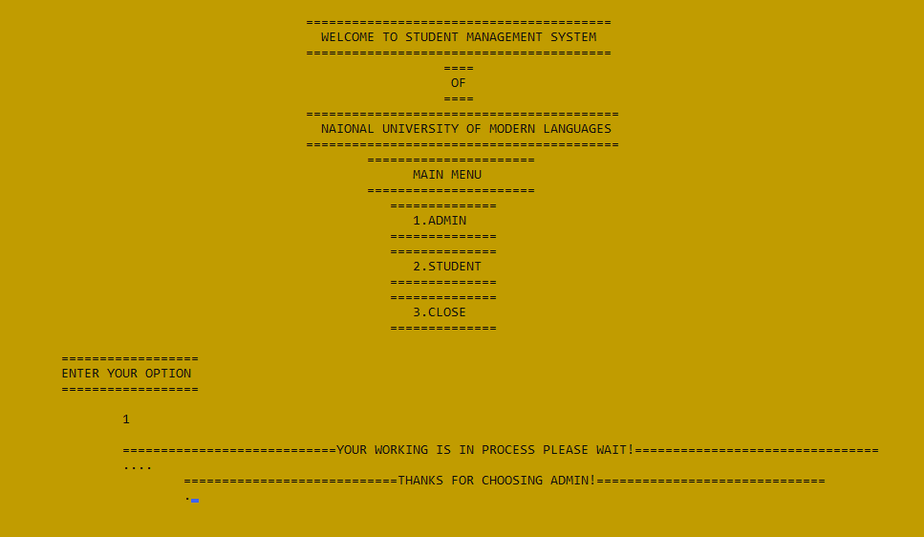

**ADMIN SCREEEN:**

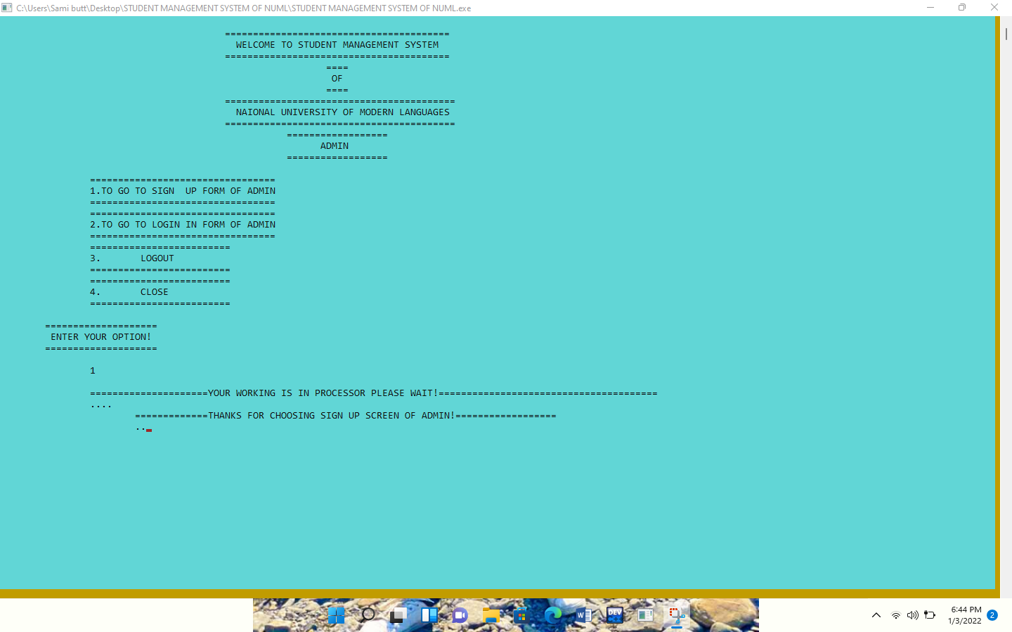

**ADMIN SIGNUP SCREEN:**

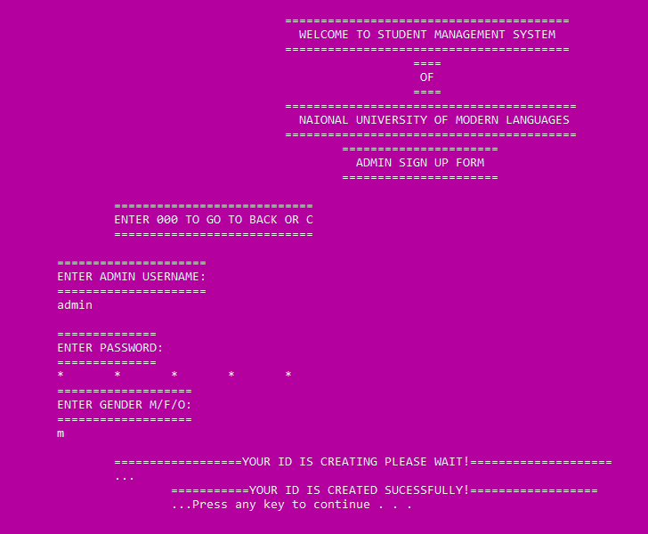

**ADMIN LOGIN SCREEN:**

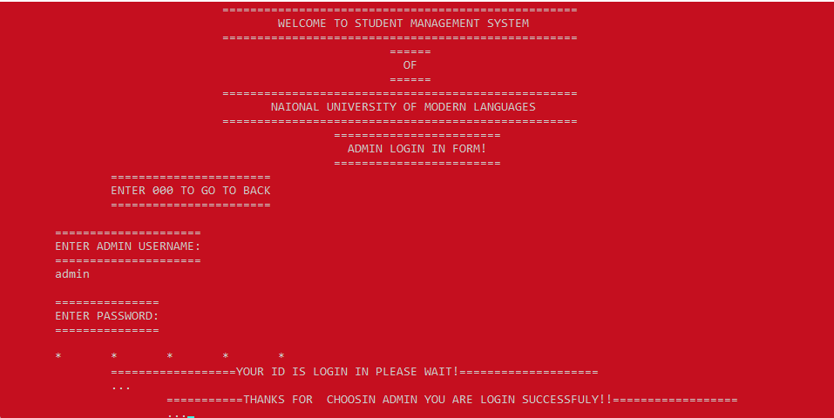

**ADMIN SCREEN AFTER LOGIN:**

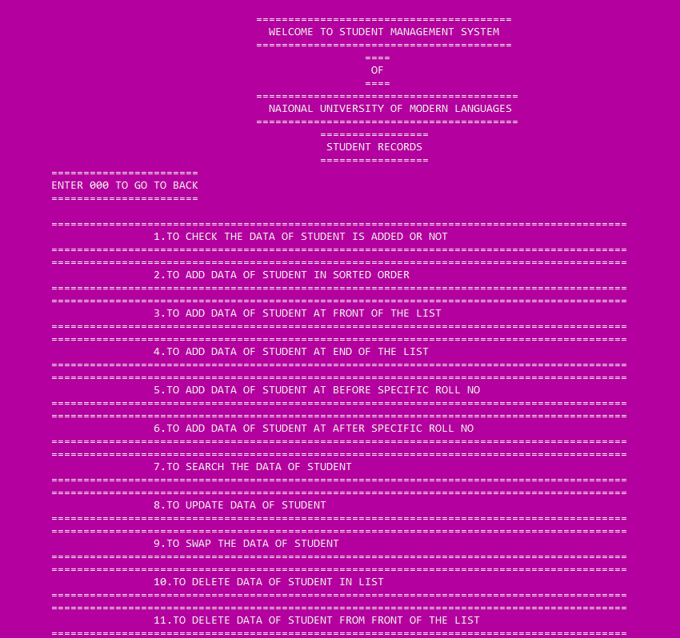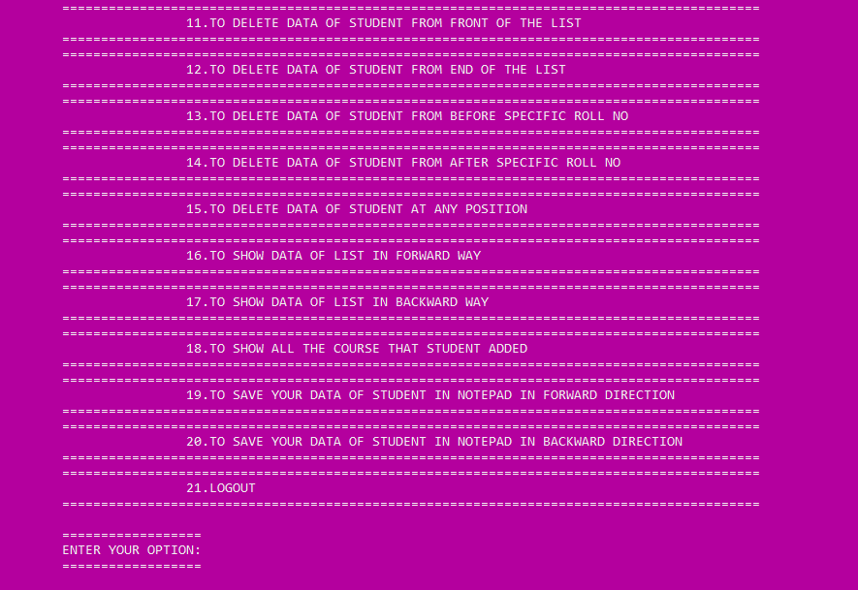

**STUDENT SCREEN:**

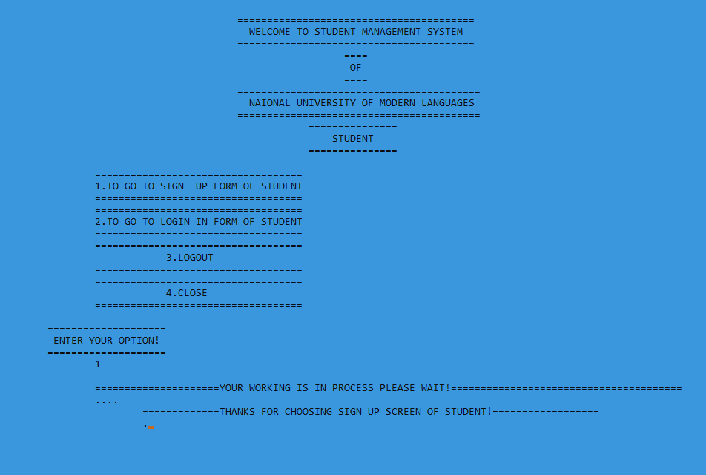

**STUDENT SIGNUP SCREEN:**

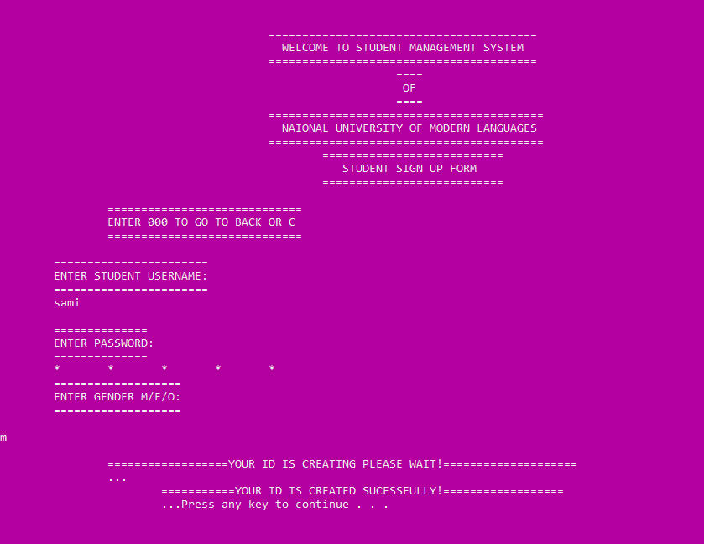

**STUDENT LOGIN SCREEN:**

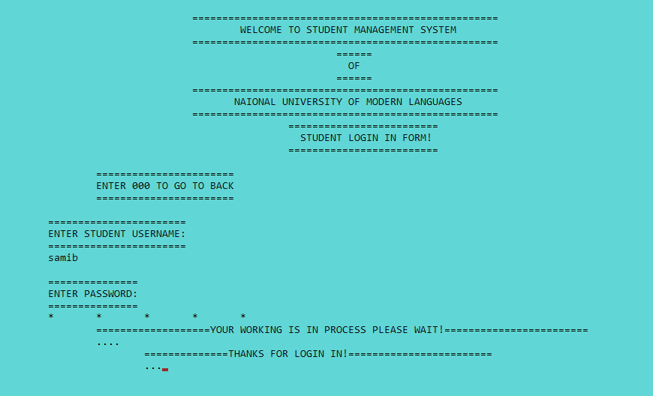

**STUDENT AFTER LOGIN SCREEN:**

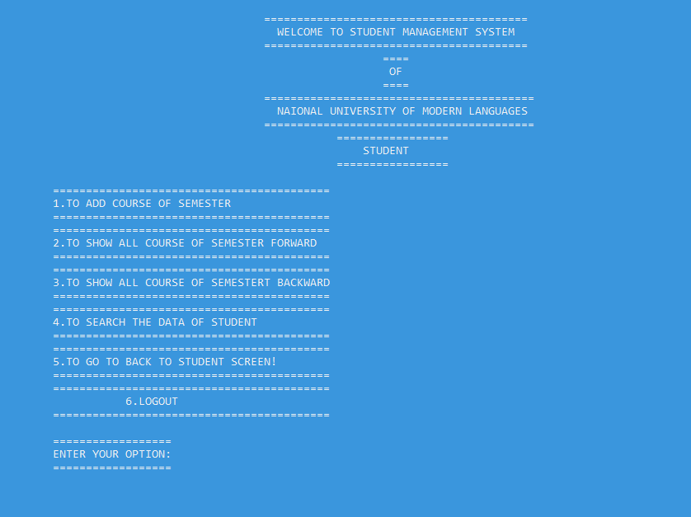

**Work Requirements of Project:**

In this project first we need to create an cpp file which name is **Student management system of numl** and then we start our coding first we need to declare our header file in this project. That which we are using in our project. we are using these header files in our project.

* #include<iostream>
* #include<windows.h>
* #include<conio.h>
* #include<string>
* #include<fstream>

**#include<iostream>:**

In This Header File **#** is a Preprocessor directive and **iostream** is an header file or an parent class or a library and **include** is a statement which linked the preprocessor directive with iostream header file.

**#include<windows.h>:**

**Windows.h** is a Windows-specific header file for the C++ programming languages which contains declarations for all of the functions in the Windows API stand for Application Programming such as the function of **Sleep ();**

**#include<conio.h>:**

* The **conio.h** header file used in C++ programming language contains functions for console input/output. Some of its most commonly used functions are clrscr, **getch, getche**, **kbhit** etc.
* They can be used to clear screen, change color of text and background, move text, check whether a key is pressed or not and to perform other tasks

**#include<string>**

* Strings are used for storing text.
* A string variable contains a collection of characters surrounded by double quotes:
* To use strings, you must include an additional header file in the source code, the **<string>** library

**#include<fstream>**

* **<fstream>** library provides functions for files, and we should simply add **#include <fstream>** directives at the start of our program.
* To open a file, a filestream object should first be created. This is either an **ofstream** object for writing, or an **ifstream** object for reading.
* The declaration of a filesream object for writing output begins with the **ofstream**, then a name for that filestream object followed by parentheses specifying the file to write to: **ofstream object_name ("file_name");**

**Ios:**

|  |  |
| --- | --- |
| ios | Description |
| ios::out | Open a file to write output |
| ios::in | Open a file to read input |
| ios::app | Open a file to append at the end |
| ios::ate | Open a file without truncating, and allow data to be written anywhere in the file. |
| ios::binary | Treat the file as binary format rather than ASCII so that the data may be stored in non-ASCII format. |

* In this we are also creating an user defined data types for to get all the information that we are using in our project we are using **struct** to define an user defined data type.
* In this project we are using **Circular Doubly Linked List.** So we need two pointer first prev and second is next and also we declare our data which we are using in it

struct node

{

node *prev;

string ssubject, studentname, fathername, emialid, deparment, studentaddress, studentdob,studentcampus,sextracurricular,cinicno,contactofstudent, contactoffather;

int semestermarks,studentsemester,studentrollno,studentfees;

float studentcgpa,studentper,studentgpa;

node *next;

};

struct node *tail=NULL;

struct node *location=NULL;

struct node *predlocation=NULL;

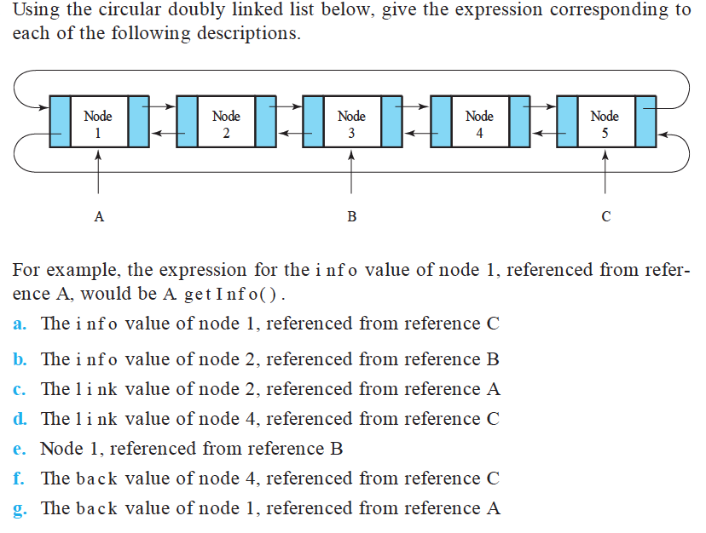

* This **struct** is used to create an **Circular Doubly Linked List.**
* In Circular Doubly Linked List when we are implementing this operation such as insertion at front insertion at end insertion at before specific value and insertion at after specific value or many other operations that which we are implementing using Circular Doubly Linked List
* Let’s we say that we have a head pointer pointing to the first node of the linked list
* For this we need the address of the last node of the list
* Because we have to update the link part of the last node so that it can point to the new node
* In order to take the address of the last node we have to traverse the whole list
* Similarly if we want to add a new node at the end of the list then also the whole list has to be traversed.
* Thus if we keep a pointer to the last node in the circular linked list then there is no need to traverse the list in order to perform both the operation.
* That is why we are keeping a tail pointer instead of head pointer in circular linked list.
* If we are adding the data at front of the list we should must have some pointer on first node of list which named as **location pointer** such that it declare as **location=tail->next.**
* In this Project we are also using file handling for this we used an header file which name is #**include<fstream>** This Operation Provide Both functionally to read and write the .**txt** file in a program.
* In this we are using some advance concept of C++ Programming Language

To Handle All the condition that user are disturb form and in this project over main purpose is to reduce the time of the user in an efficient way

So that why we are using some advance concept to handle the huge data in Better way

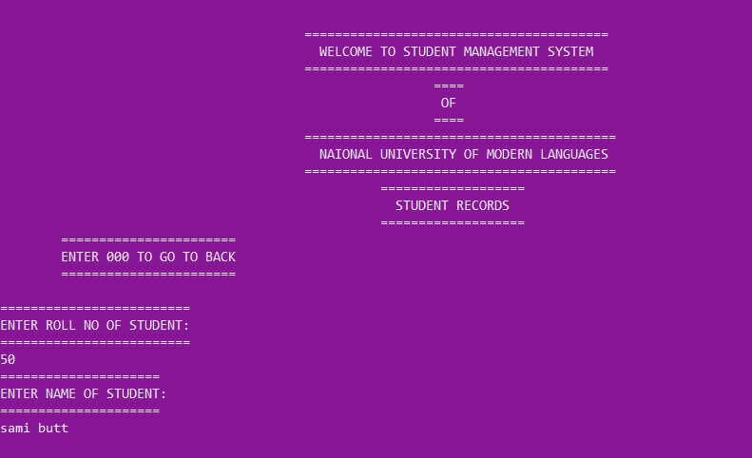**Insert the Data of Student in Sorted Order:**

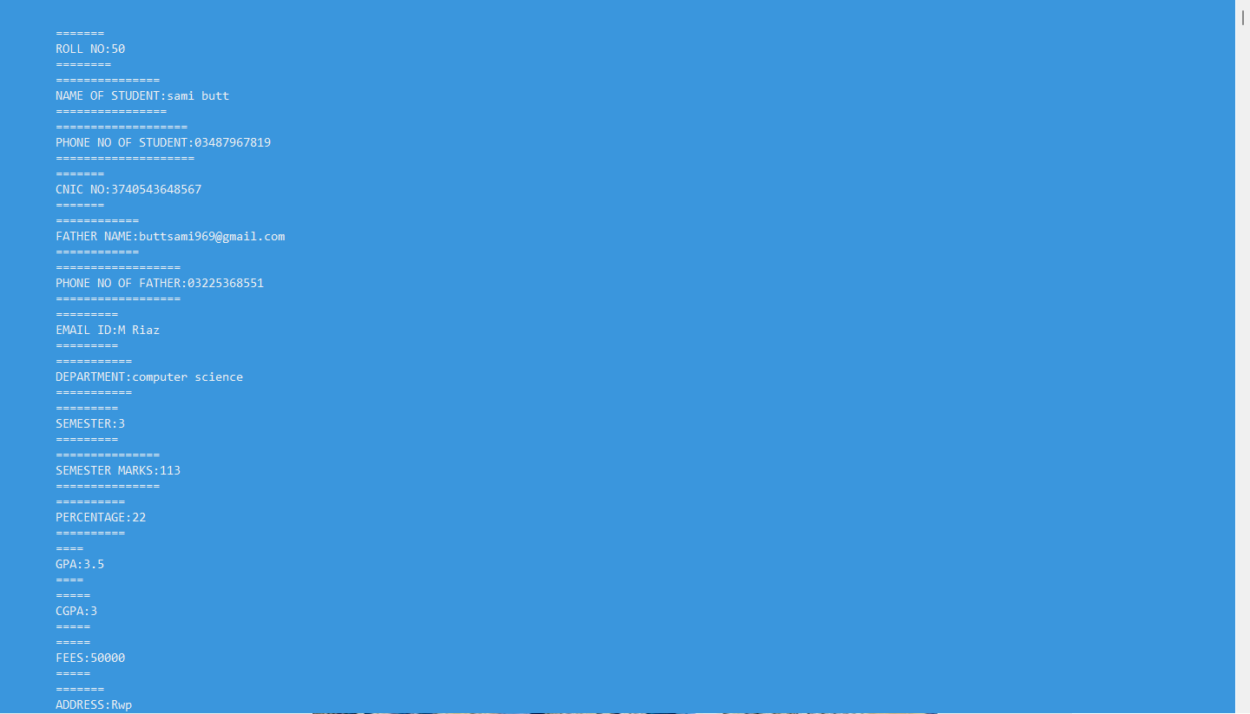

* Remaining operation that which we are using in this project
* We are used to show them through when we are executing the program of our project student management system.

**Work Distribution:**

|  |  |
| --- | --- |
| ***Work Distribution:*** | |
| **SAMI BUTT** | All theory are written by him with the help of his group members And file handling is implemented by him and all deletions operations and he also beautify the code to get good output |
| **NIMRA AKRAM** | She is implementing these operation in this project such as all operation of insertion by her and also she make over presentation slides. |
| **KASHIF NAWAZ KHATTAK** | He is Implementing these operation Traverse, update,cgpa calculation,gpa calculation, swapping |

**Conclusion of the Project:**

The conclusion of this project is that we are using data structures and algorithm to store larger number of data of the student through **Circular Doubly linked List** in which we are able to handle the large number of data in sequential order and maintain the data in best way to understand by the user and it may decrease the time of the user for when they are storing the huge data of the student. This linked list is more efficient as compare to other linked list.

**Lesson Learnt:**

Through this project we have learned that how to manage the institute records of student or any other place that in which we are used to handle huge data and to manage that in an sorted order and make the user to understand the records easily and frequently by using Data Structure And Algorithm.

**THANK YOU!**